Name:

Year | Section:

Date: May 15, 2024 – **Deadline will be today at 6:25 PM only.**

This must be the name of your word document – LASTNAME_INITIAL(APPDEV-MID) **TUNGUL_RD(APPDEV-MID)**

**(MIDTERM EXAM) APPLICATION DEVELOPMENT**

1. Create a Copy and Paste website content that can cater the audience need (i.e. copying the machine/devices text or files):

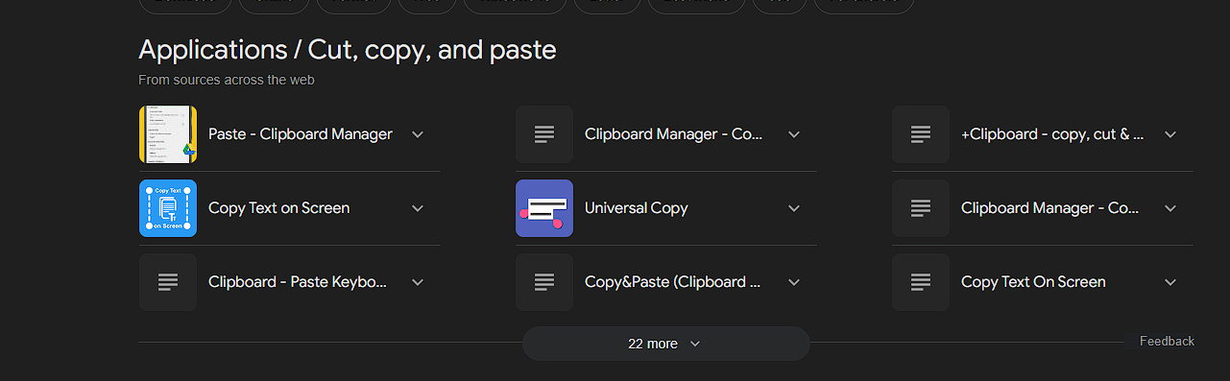

1. Upload your file via GitHub and named it as: username.github.io/appdev-midterm
2. Create your own sentence/wordings and replace all the Lorem ipsum text into your generated sentences. Add a metadata inside the head section. Please make sure that your design is 1:1, unique, and up to date:

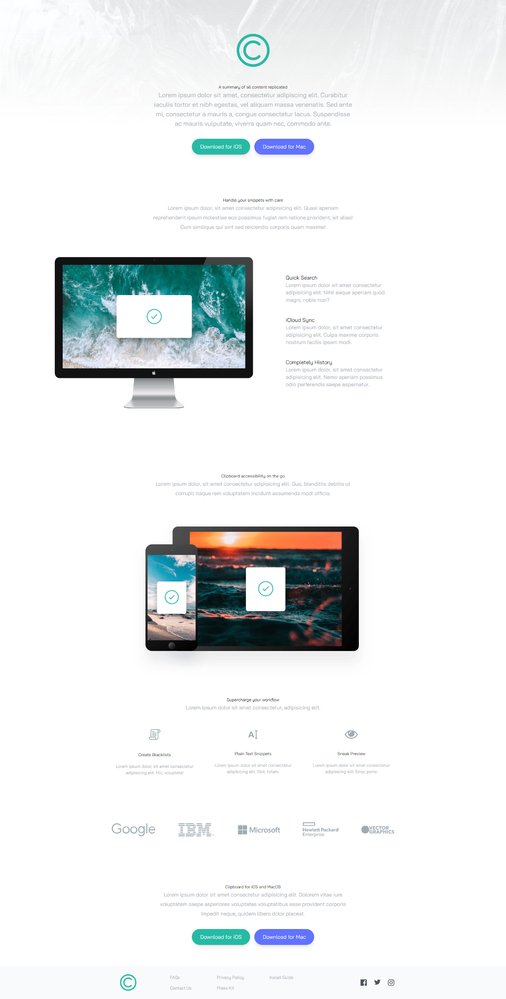

1. Make the site’s speed up to 98% on all aspects using Google PageSpeed Insights.
2. Network speed must be faster than the original speed. (Note: speed must be less than 2.5 seconds)

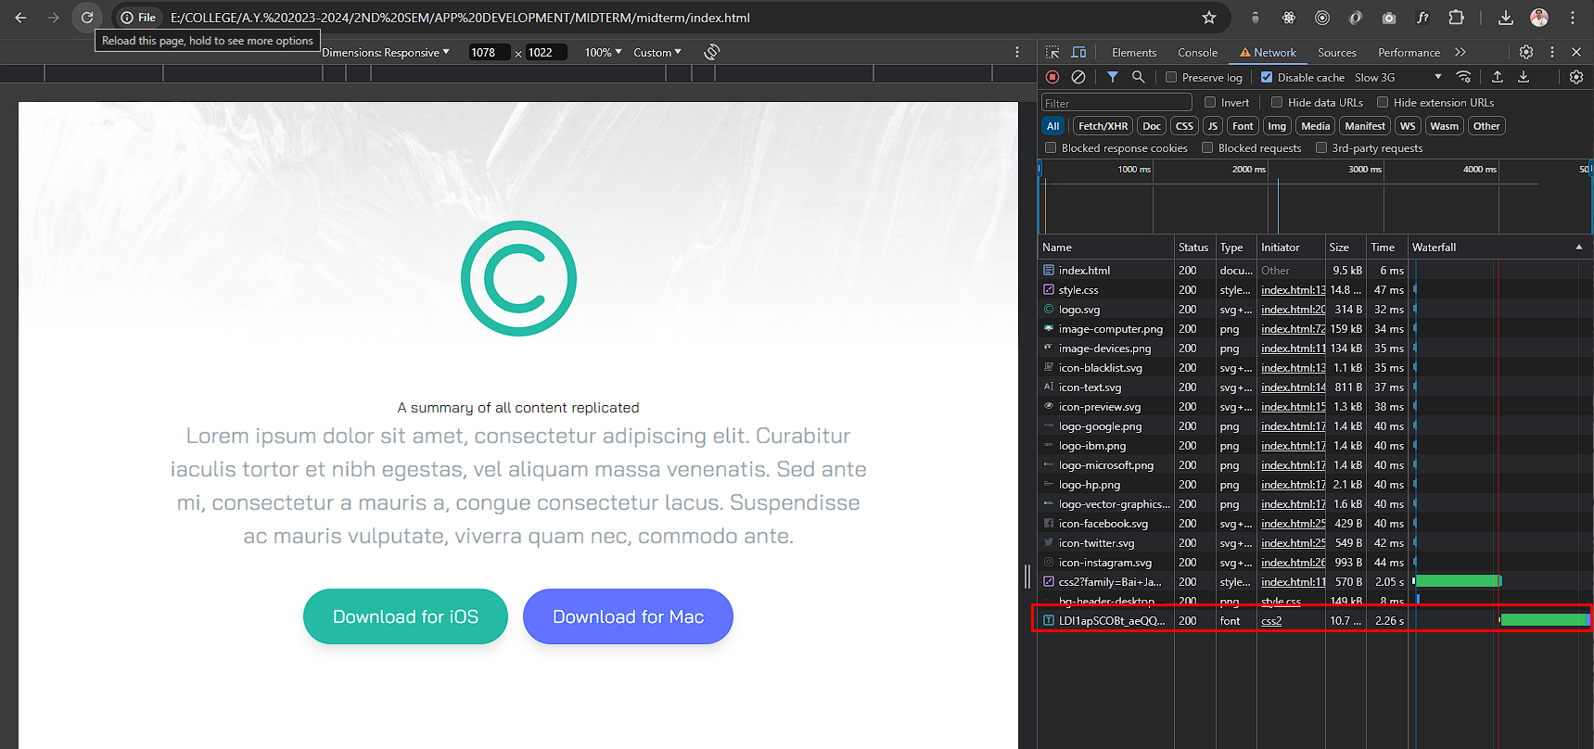

Save your screenshots here:

Save your code here:

Note: Duplicate design for the resume will be investigated and reviewed.

Goodluck and keep going! You can do it!

___________________

**Roseph Darl Tungul**

Instructor